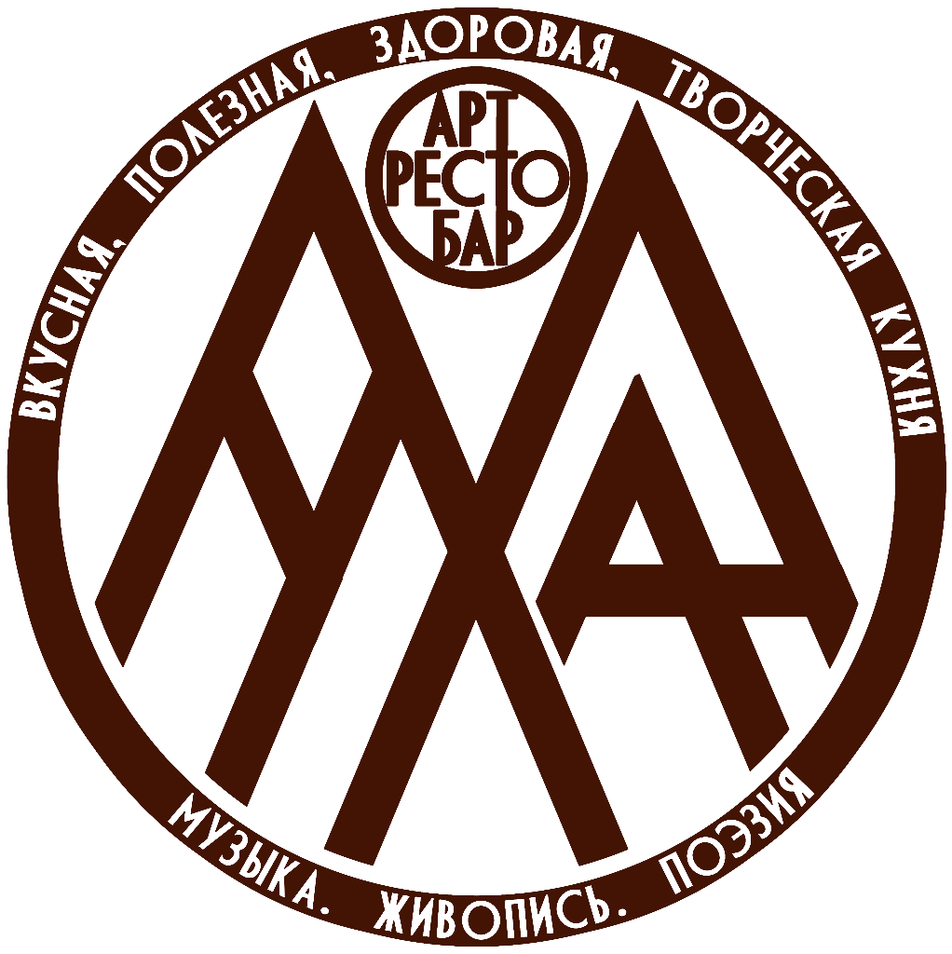
Technical rider
MUHA Art Bar & Restaurant
Equipment and connection arrangements must be agreed with the venue administrator in advance.

Item | Qty | Specifications
Standard live performance equipment
Mackie-12 analogue mixing console | 1 unit | 12 channels; 4 microphone preamps; 3-band EQ per channel.
B-115D powered loudspeakers | 2 units | Power: 1000 W.
AKG-Pro wireless dynamic vocal microphones | 4 units | For vocals and presenters.
Behringer dynamic vocal microphones | 4 units | For vocals and presenters.
Microphone stands | 4 units | Standard performance stands.
Guitar stands | 2 units | For guitars / bass guitars.
Keyboard stand | 1 unit | For keyboard instruments.
Equipment available by prior arrangement
Sonor Smart Force acoustic drum kit | 1 unit | Full-size acoustic drum kit.
Roland TD-1 electronic drum kit | 1 unit | Electronic drum kit.
Yamaha PSR 520 synthesizer | 2 units | 61 keys.
Artesia PA-88H MIDI keyboard | 1 unit | Full-size hammer-action keyboard.
Soundcraft UI 24 R digital mixing console | 1 unit | Digital mixer for expanded routing.
Leem Proaudio NWX-18B subwoofers | 2 units | Power: 1200 W.
Behringer NX3000 amplifier | 1 unit | 2 × 1500 W.
Hiwatt Maxwatt G100R guitar combo amplifier | 1 unit | Power: 100 W.
Hiwatt-Maxwatt B300HD bass cabinet | 1 unit | Power: 300 W.

